SEEDS of Early Literacy

2014-2015 Spring Benchmark Aggregate Data –

4 Year Olds

This data represents the 2014-2015 Spring Benchmark data collected on all 4 year olds assessed. The data was collected between April 27, 2015 and May 20, 2015.

This report is broken into three sections.

* Section I includes all 4 year olds tested
* Section II includes all TK 4 year olds within OUSD
* Section III includes all TK 4 year olds outside of OUSD
* Section IV includes all Pre K 4 year olds within OUSD
* Section V includes all Pre K 4 year olds outside of OUSD

**Section I: All 4 year olds**

* A total of 42 classrooms were assessed:
* 37 classrooms had assessments conducted in English only
* 4 classrooms had assessments conducted in the child’s dominate language with the choice of English or Spanish
* 1 Classroom has assessments conducted in Spanish only

**All 4 Year Olds Tested in English : % at Each Target Level**



*This table represents the percentage of all 4 year olds tested in English at each target level for each assessment

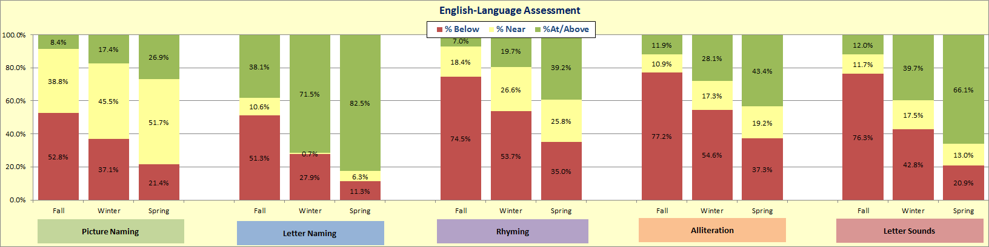

**All 4 Year Olds Tested in English: % At or Above Target Level**

*This table represent the percentage of all 4 year olds tested in English who scored at or above the target level for each assessment.

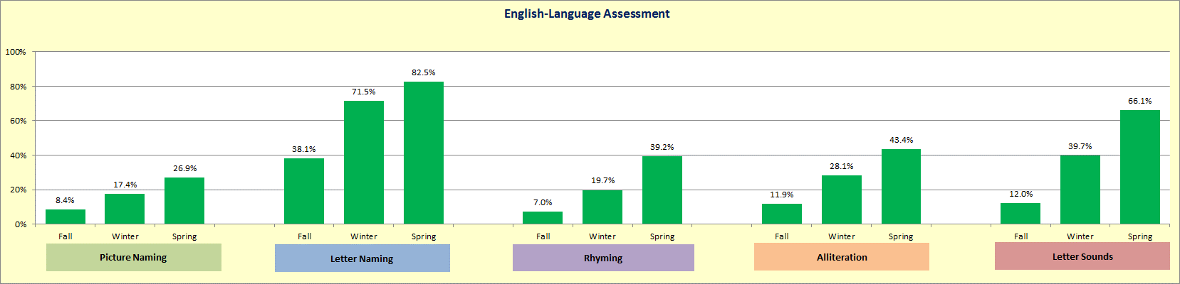

**All 4 Year Olds Tested in Spanish: % at Each Target Level**



*This table represents the percentage of all 4 year olds tested in Spanish at each target level for each assessment

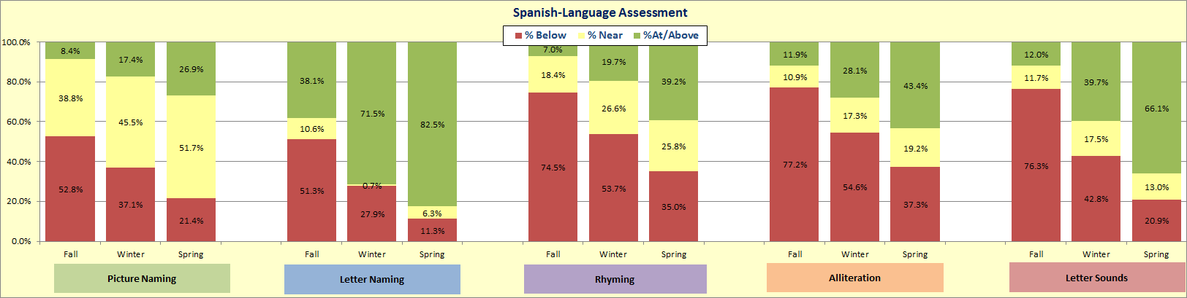

**All 4 Year Olds Tested in Spanish: % At or Above Target Level**

*This table represent the percentage of all 4 year olds tested in Spanish who scored at or above the target level for each assessment.

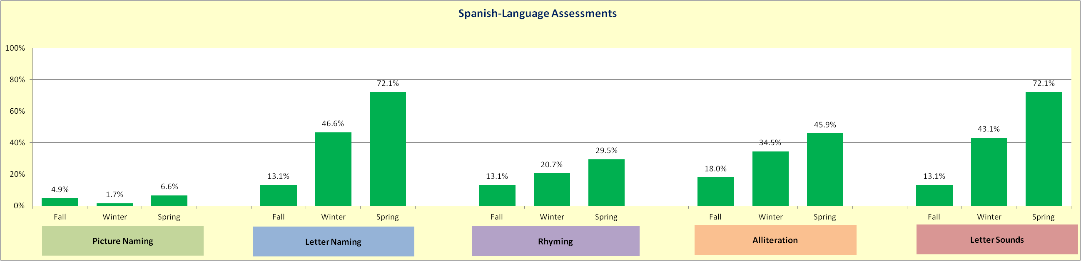

**Section II: TK 4 year olds within OUSD**

A total of 34 classrooms were assessed:

* 28 classrooms had assessments conducted in English only
* 4 classrooms had assessments conducted in the child’s dominate language with the choice of English or Spanish
* 1 Classroom has assessments conducted in Spanish only

**TK 4 year olds within OUSD English: % at Each Target Level**

*This table represents the percentage of 4 year olds tested in English at each target level for each assessment who are enrolled in OUSD.

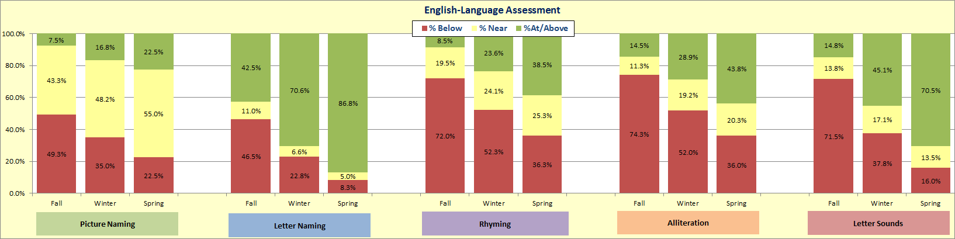

**TK 4 year olds within OUSD English: % At or Above Target Level**

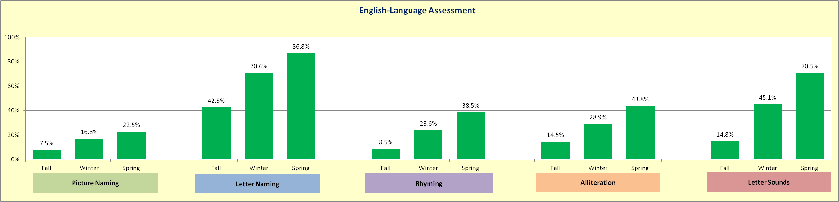*This table represent the percentage of 4 year olds tested in English who scored at or above the target level for each assessment who are enrolled in OUSD.

**TK 4 year olds within OUSD in Spanish: % at Each Target Level**

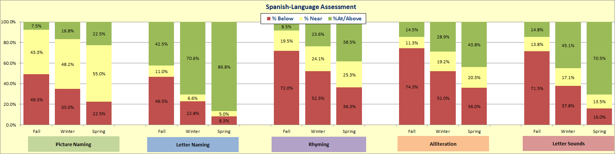* This table represents the percentage of 4 year olds tested in English at each target level for each assessment who are enrolled in OUSD.

**All 4 Year Olds Tested in Spanish: % At or Above Target Level**

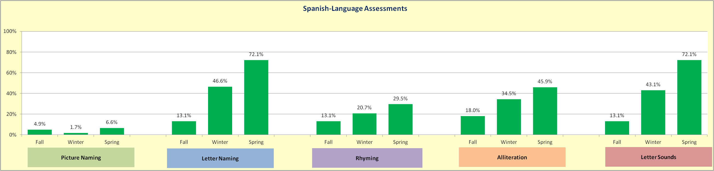* table represent the percentage of 4 year olds tested in Spanish who scored at or above the target level for each assessment who are enrolled in OUSD

**Section III: TK 4 year olds outside of OUSD**

A total of 8 classrooms were assessed. All assessments were conducted in English.

**TK 4 year olds outside of OUSD: % at Each Target Level**

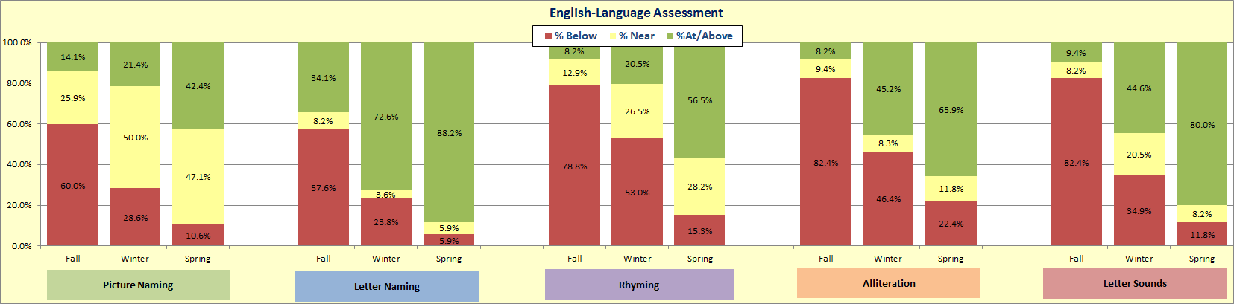*This table represents the percentage of 4 year olds tested at each target level for each assessment who are not enrolled in OUSD

**TK 4 year olds outside of OUSD: At or Above Target Level**

*This table represent the percentage of 4 year olds tested who scored at or above the target level for each assessment who are not enrolled in OUSD

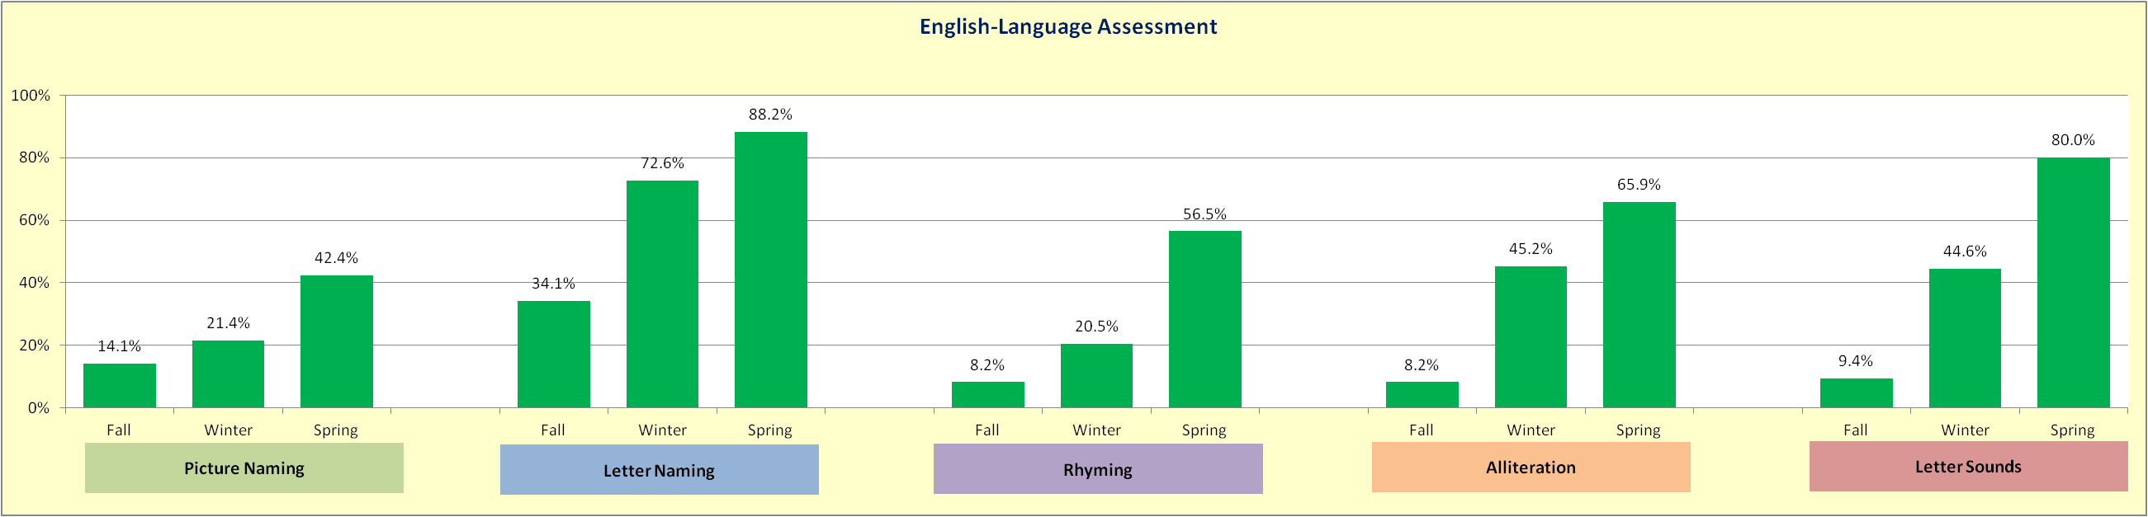

**Section IV: Pre K 4 year olds within OUSD**

* A total of 3 classrooms were tested in English Only

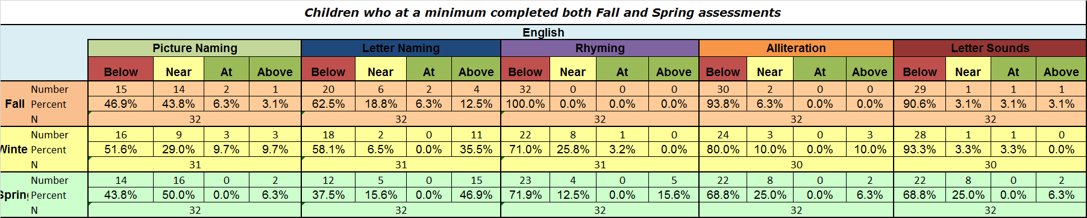**Pre K 4 year olds within OUSD: % at Each Target Level**

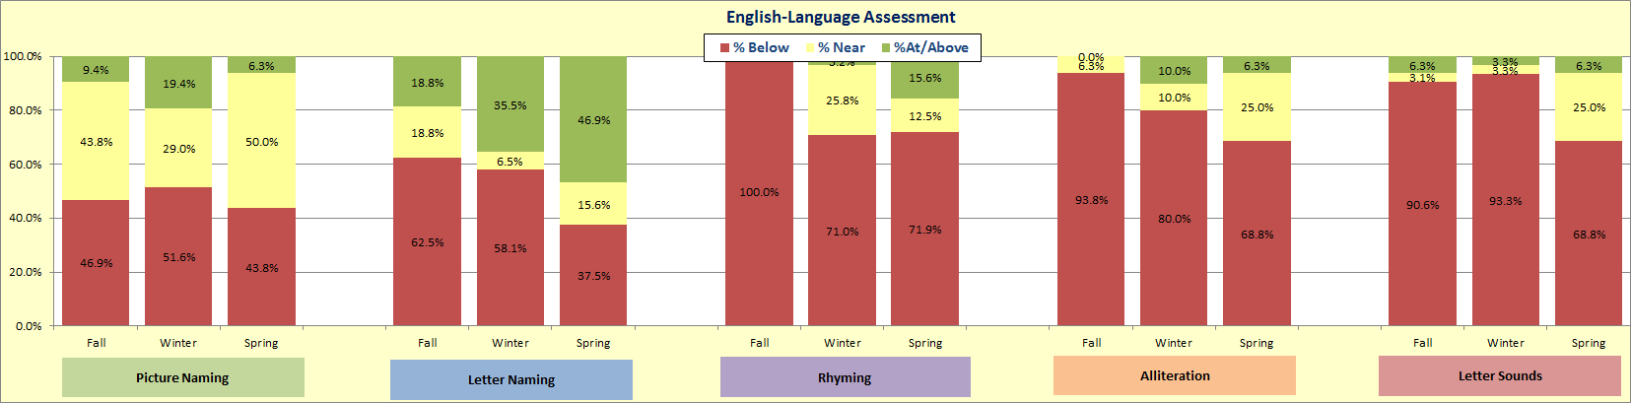*This table represents the percentage of 4 year olds tested at each target level for each assessment who are enrolled in OUSD.

**Pre K 4 year olds within OUSD: % At or Above Target Level**

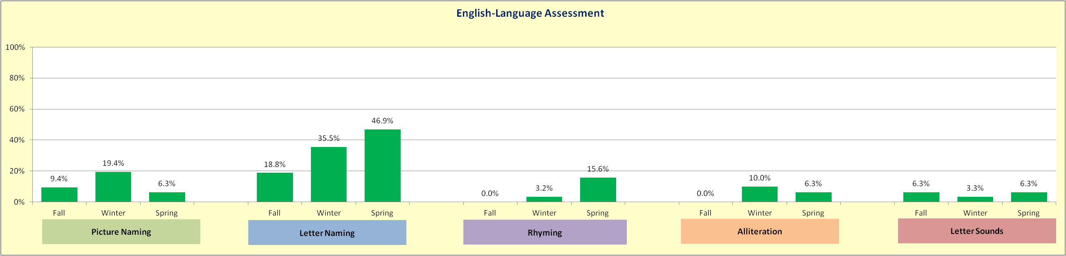*This table represent the percentage of 4 year olds tested who scored at or above the target level for each assessment who are enrolled in OUSD.

**Section V: Pre K 4 year olds outside of OUSD**

* A total of 7 classrooms were assessed in English Only.
  + Of which only 5 classrooms had 4 year olds.

**Pre K 4 year olds outside of OUSD: % at Each Target Level**

*This table represents the percentage of 4 year olds tested at each target level for each assessment who are not enrolled in OUSD.

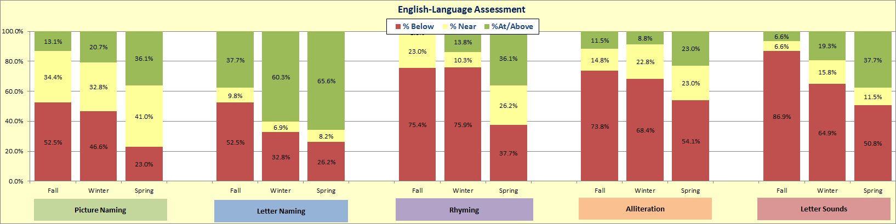

**Pre K 4 year olds outside of OUSD: % At or Above Target Level**

*This table represent the percentage of 4 year olds tested who scored at or above the target level for each assessment who are not enrolled in OUSD.

