









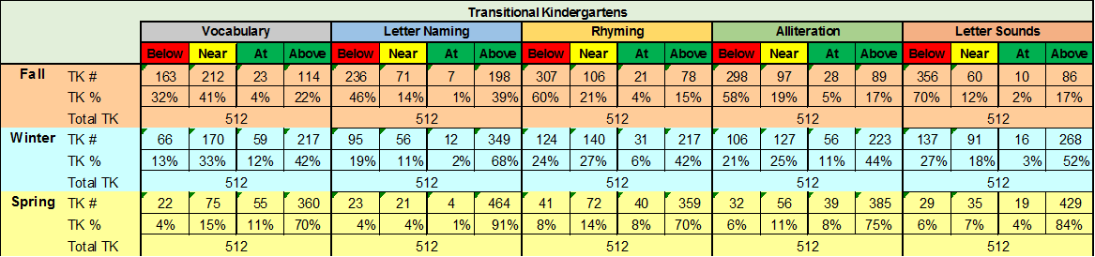

|  |  |  |  |
| --- | --- | --- | --- |
| School year | # of children in data set (fall, winter and spring scores) | # of children from data set who ended the school year (spring) with mastery in all 5 skills | % of children from data set who ended the school year (spring) with mastery in all 5 skills |
| 2017-2018 | 510 | 309 | 61% |